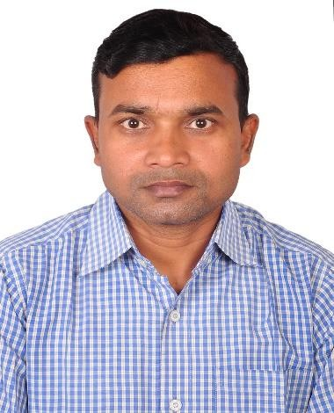

***CURRICULUM VITAE***

***Mr. SHIV KUMAR CHAUDHARY***

**Mobile: *+919630279009***, ***+919479530101***

# E-mail: [kshiv18@gmail.com](mailto:kshiv18@gmail.com)

**Career Objectives:**

* To succeed in an environment of growth and excellence and earn a job which provides me satisfaction and self-development and help me to achieve organizational goal.
* To make a sound position in corporate world and work enthusiastically in team to achieve goal of the organization/MNC with devotion and hard work.
* To seek challenging assignments and responsibility, with an opportunity for growth and career advancement as successful achievements.

# Area of Interest:

Operations, Quality-Sourcing, Sales & Marketing B2B & B2C Segment, E-Commerce,

# 

# Academic Qualifications:

# 

* MBA in (Operation Management) From Subharti University, Meerut in 2017)
* BBM in (Operation Management) From National Institute of Business Management & Technology, New Delhi in 2015)
* Certificate in Quality Management for Business Excellence in 2024 by Udemy
* 10+2 (From U.P Board of Allahabad in 2003 with science Stream
* Diploma in Footwear Technology in 2007 from MSME Kanpur

# Skills: -

# Inventory Management, Leadership, Vendor Communication, Production, Quality Control

* MSOFFICE, Word, PowerPoint, Excel, SAP, INCREFF, WMS

# 

# Summary of skills:

**Ethical Quality Assurance with Best Production**

Self-disciplined in assuring the quality and productivity of merchandise and ensuring the quality output from the vendors at all times by strictly following the company policy.

Strong belief in systems and procedures; and in providing practical solutions at the early stage, rather than finding the fault at the end and Racing to solve Problems ensuring total involvement to get the optimum result.

# Industrial Experience: -

* Currently working at **Arvind Fashions Ltd. as** an Asst.Production Sourcing-Quality Manager from October 2018. Looking here **Footwear, Apparel & lifestyle**

# International Brands E.g.,US POLO, Arrow, Ed Hardy, Cole-Haan, Flying Machine, Aeropostale, Gap, Stride, True Blue etc & WH operation.

* Worked at **Adidas Sports India Pvt. Ltd.** Gurgaon **an** E-commerce Retail store as Quality Executive from Dec. 2017 to October 2018.
* Worked at **TATA INTERNATIONAL LIMITED**, Dewas from Feb.2013 To Dec. 2017 as a **Senior Production Executive**. Taken up production charges of international ladies & Men’s Footwear with full efficiency to take in a large quantity with maintaining of quality by cost cutting in terms of workers and rejection.
* Worked at Be Stylish.com as a Quality Executive from January 2012 to January 2013. **Be Stylish.com is** an Ultimate Men’s Lifestyle & Fashion website online retailer committed to delivering an exceptional shopping experience in India.
* Worked **at TATA INTERNATIONAL LIMITED**, Dewas from May 2010 to December 2011 as a Supervisor in the Production Department. Looked Brands like ZARA, TESCO, HUSHPUPPIES, BEXLEY, ASTROMUELLER

# H&M, SCHEIMENGER, J.C Penny, Fenili , Bugatti, Bata, Aldo, ARA Current job

# Profile: -

* Looking domestic & international partners Sourcing Quality along with WH operation Responsible for Dispatch department like process order to customer delivery with good quality. Looking operations and Quality of all Footwear, Apparel’s and other accessories.
* Minimize rejections and repair to maximize the profits.
* Complete operations within TAT without any deviation.
* To check Testing Reports as per Product Needs.
* To check every Sample for new season at Vendor plant and follow technical comments
* To make Sample for Photo-shoot / Salesman.
* To check Pre-Production trail of every new article at vendor plant as per Planning.
* To check every Process at Vendor floor as per Product Needs.
* Supporting Vendors for deviations by penalty / approval.
* To make Inspection report of every article after successful closer.
* Circulating MIS report on daily basis.
* Coordination with Merchandising, Sales and Supply chain.

# Personal Expertise:

* + Highly pro-active, go-getter and Team Player
  + Ability to manage multiple assignments successfully within the dead line & schedule.
  + Proven capacity to approach problems effectively and creatively.
  + Aggressive hard worker with strong commitment
  + Quick Learner & flexible to change

# Personal Profile:

**Father’s Name :** Mr. Shiv Murti Chaudhary

**Sex** : Male

**Date of Birth :** 25-07-1985

**Permanent Address** : Village- Pershoura

: P.O.- Majhoua -Babu

: Tehsil- Harraiya Distt. Basti (U.P.) Pin.27213

**Marital Status :** Married

**Nationality :** Indian

**Languages Known :** English , Hindi & Punjabi

**Declaration**

I hereby declare that the above-said information is true to the best of my knowledge and belief.

Place: Bangalore

SHIV KUMAR CHOUDHARY